**Team Green Project Journal:**

**Assignment: Team 01 Project**

**Completion Date: 3/18/2021**

**Specified Roles:**

Team Leader - Sarah Shoup

Asset Manager - Parker Hague

Documentarian - David Hiltzman

GitHub Repo: <https://github.com/ParkerH98/Team_Green> (Private Repo, so will need to be shared)

**What we built:**

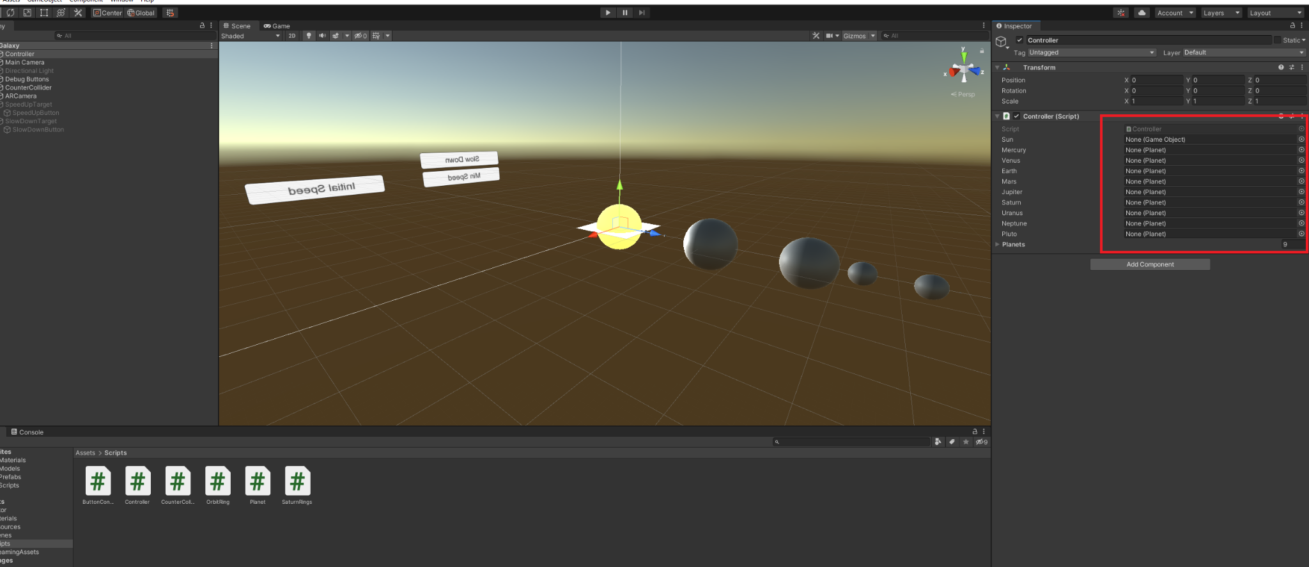

We created a solar system that rotated at specified rates provided by the Extended Reality class. Parker chose three pictures that will be the basis of our project.

The Sun picture is the middle of the solar system, which is below the Sun that orbits around the solar system. Parker created a basic system that specified orbits with the GameObjects given a Planet Tag. Using a script, the GameObjects could be sped up and slowed down.

Sarah created and rendered the rings of Jupiter.

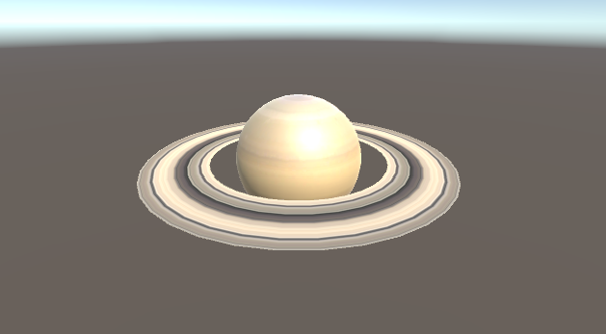

The team used a Tail Renderer to simulate the planet orbits. There were some very obvious issues that we encountered, but we mitigated them with a script and lowering the orbit line.

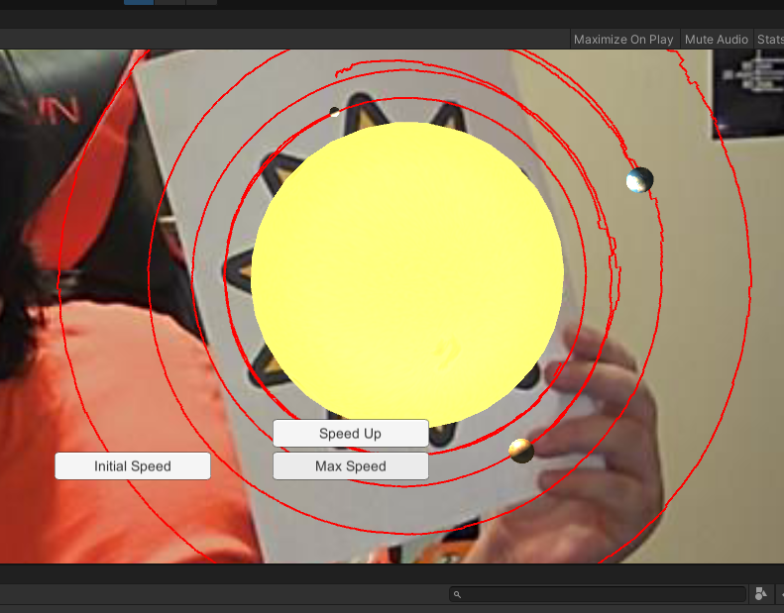

The buttons were created using the two pictures. The Team created 2 target images, added a Virtual Button as a child to each of them, then added scripts to control what the buttons did while "pressed".

**Basic Tasks Assigned:**

Sun Glow - Robby

Orbit Rings - David

Saturn's Rings - Sarah

ARify - Simon

Speed - Brady

**Issues we encountered:**

One of the major issues we encountered was the orbits being very wacky, and generating very oddly. The reason we discovered this was because the program had no place for them to generate. As the program progresses, the orbits would fix themselves. This was because the Vuforia camera had some time to process. We beat the issue by adding a wait timer in the script that kept the emitter turned off for a couple of seconds. We then reduced the trails to a few seconds. It still gives the orbits, but doesn’t overwhelm the system.

We didn’t get to complete the Virtual Buttons, we kept the UI buttons to show functionality. This was given to a specific team member a week prior to the due date, and it was not completed. After a quick review before submitting, we decided to best to just eat the deduction instead of waiting on this team member to complete it.